Jubilee Marie Tantoy

2 ECE D

**EXPERIMENT NO. 9 : DATA WRANGLING USING PANDAS**

Problem No. 1

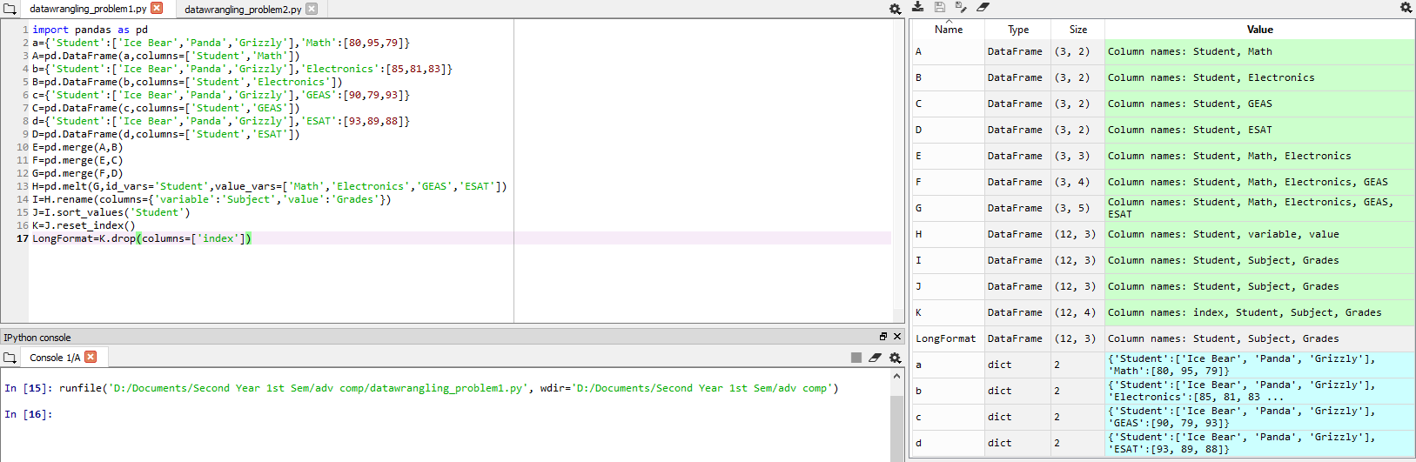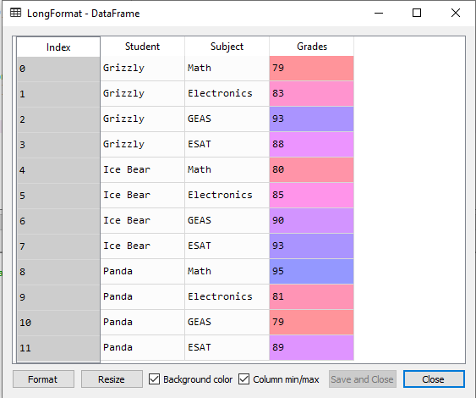

Problem No. 2

